**DAILY ONLINE ACTIVITIES SUMMARY**

|  |  |  |  |  |  |  |  |
| --- | --- | --- | --- | --- | --- | --- | --- |
| **Date:** | 06-07-2020 | | | | **Name:** | Gudugunti Anirudh | |
| **Sem & Sec** | IV - A | | | | **USN:** | 4AL18CS023 | |
| **Online Test Summary** | | | | | | | |
| **Subject** | | Engineering Mathematics-4 | | | | | |
| **Time limit** | | 45min | | **Score** | | -- | |
| **Certification Course Summary** | | | | | | | |
| **Course** | C programming | | | | | | |
| **Certificate Provider** | | | Udemy | **Duration** | | | **11.5hrs** |
| **Coding Challenges** | | | | | | | |
| **Problem Statement:** 1: Given an array of integer arr[] and an integer k, the task is to find the median of each window of size k starting from the left and moving towards the right by one position each time. | | | | | | | |
| **Status:** Completed | | | | | | | |
| **Uploaded the report in Github** | | | | yes | | | |
| **If yes Repository name** | | | | https://github.com/alvas-education-foundation/anirudh_gudugunti/tree/master/daily_progress | | | |
| **Uploaded the report in slack** | | | | yes | | | |

**Online Test Details:** The test was from module 1 and there were 3 questions to solve. The time limit was 45 minutes. We had to write the test in A4 sheet and had to upload in Google classroom.

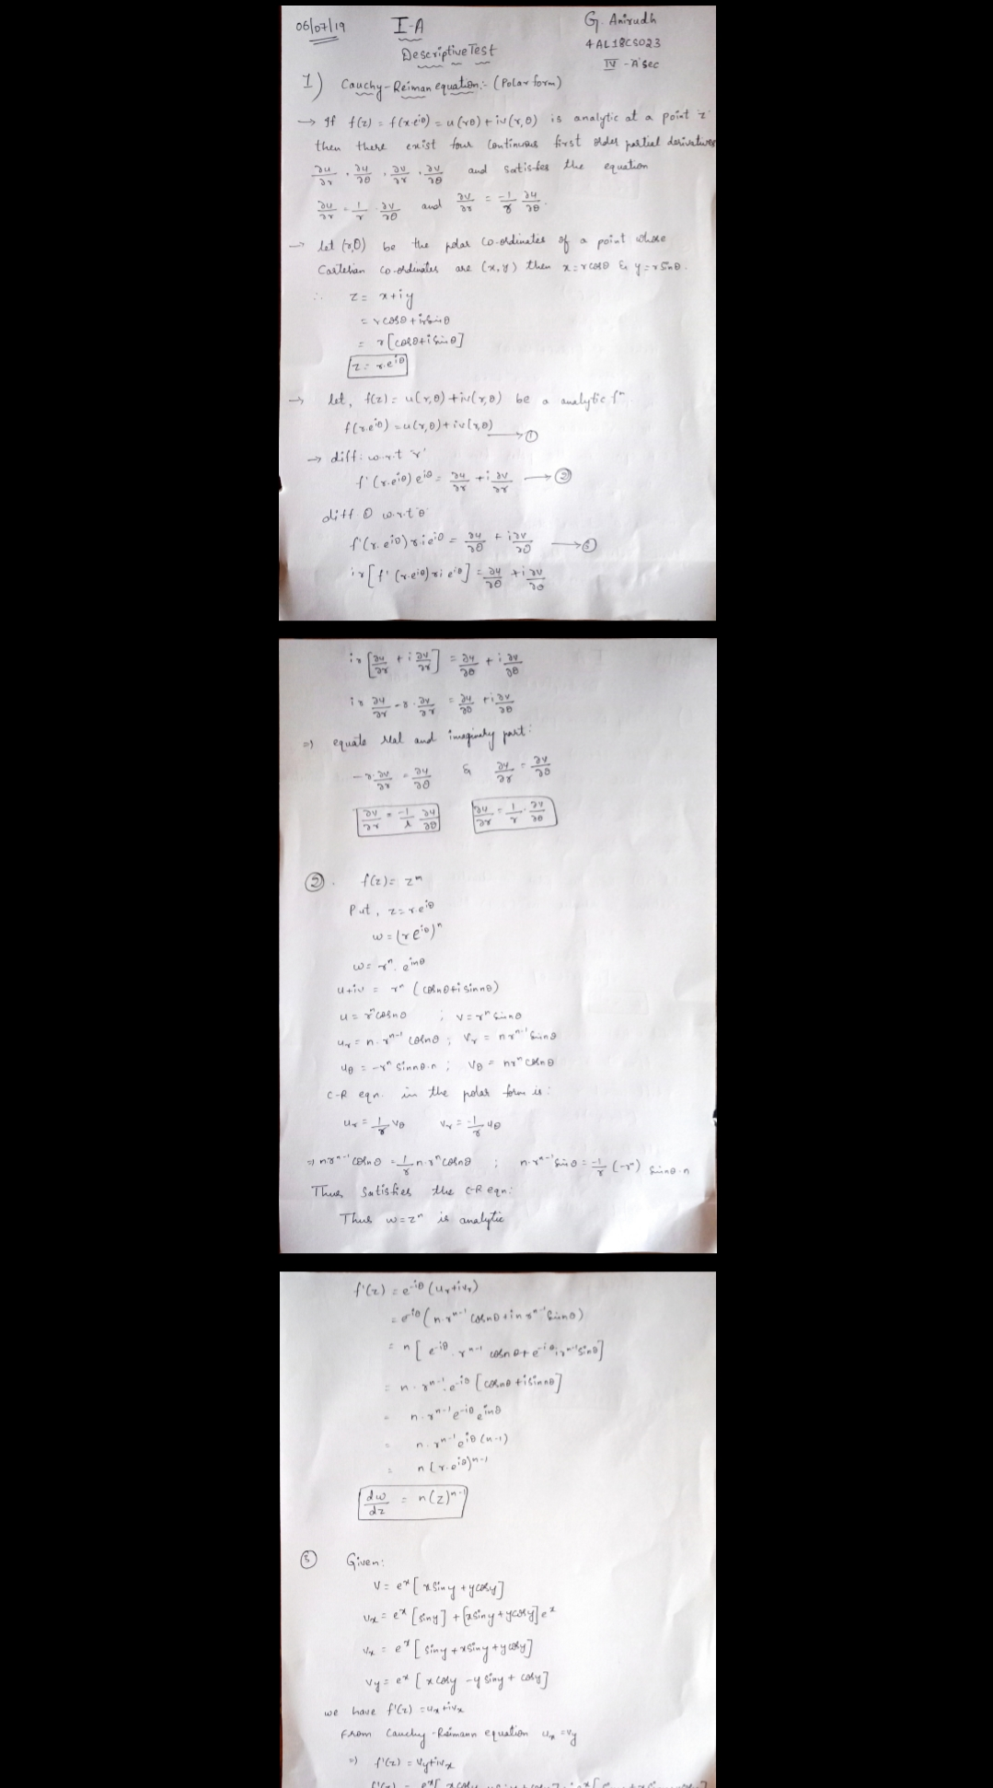

Snapshot of certification course:

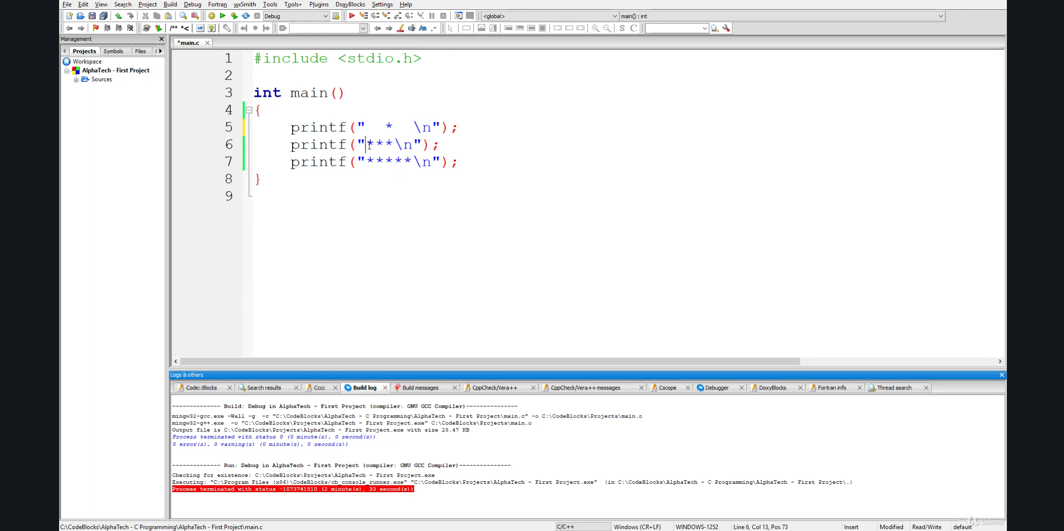

**Online coding:**

Problem 1: (using JAVA) Given an array of integer arr[] and an integer k, the task is to find the median of each window of size k starting from the left and moving towards the right by one position each time.

